Battery Charge RTT and Warnings – CGEA1.3

Functional Description

The purpose of this feature is to inform the driver of the vehicle’s electrical charging system status through a RTT and warnings.

The warnings and RTT correlate the PwSysULoFalt_D_Stat Signal from the BCM (SPDJB) and the Operational_Mode to display the warnings and activate/deactivate the RTT.

The Battery Charge RTT shall provide an iconic representation that will illuminate or extinguish the Battery Charge RTT.

This section describes the RTT and warnings function and sets a flag that is used by the Message Center display (See Message Center Section for details of Message Display Algorithm).

This STSS replaces the Battery Charge RTT – CGEA1.3 STSS.

For applications not capable of displaying a red RTT this STSS is implemented without the RTT (text only), however, if this is done then a Fixed LED red telltale must be implemented as per
“Battery Charge Telltale – CGEA1.3” STSS.

Important: FOR ALL MARKETS if the text warning in this STSS is implemented without a red RTT then a Fixed LED red telltale as per “Battery Charge Telltale – CGEA1.3” STSS is REQUIRED to ensure worldwide regulatory compliance. ECE Reg 121 Witness Authority is now rejecting use of Battery Charge related warning texts without a red Battery Charge telltale (RTT or Fixed LED is acceptable). Previously a text warning message could be used if equipped with an volt gauge with proper identifier symbol, but that is no longer accepted.

Interfaces

Interface Context Diagram (I/O Block Diagram)
Figure 1 Battery Charge RTT and Warnings Context Diagram
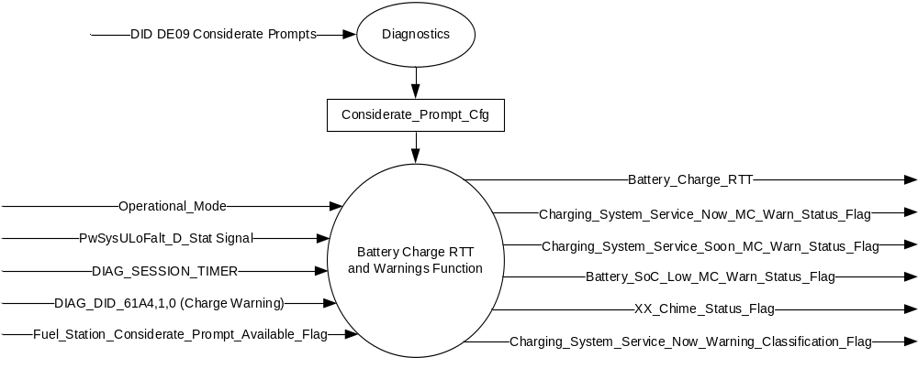

Inputs
      - INTERNAL:
            - DIAG_SESSION_TIMER
            - Operational_Mode
            - DIAG_DID_61A4,1,0 (Charge Warning)
            - Considerate_Prompt_Cfg
            - Fuel_Station_Considerate_Prompt_Available_Flag

MUX signal on the CAN Bus from the BCM (SPDJB).

- PwSysULoFalt_D_Stat Signal
Signal Name | Size (bits) | Detail | Units | Res. | Offset | State Encoded | Min | Max
PwSysULoFalt_D_Stat | 4 |  | SED | 1 | 0 |  | 0  (0x0) | 15 (0xF)
 |  | No_Fault |  |  |  | 0x0
 |  | Cluster_Proveout |  |  |  | 0x1
 |  | Fault_Nonspecific |  |  |  | 0x2
 |  | Fault_ReducedOutput |  |  |  | 0x3
 |  | Fault_NoOutput |  |  |  | 0x4
 |  | Overvoltage |  |  |  | 0x5
 |  | LowBatt1_Warning |  |  |  | 0x6
 |  | LowBatt2_PowerSaveMode |  |  |  | 0x7
 |  | LowBattVoltageDuringPwSrcOn |  |  |  | 0x8
 |  | BattMonitoringSensorFault |  |  |  | 0x9
 |  | Not_Used_2 |  |  |  | 0xA
 |  | Not_Used_3 |  |  |  | 0xB
 |  | Not_Used_4 |  |  |  | 0xC
 |  | PSS_Shed2_Contin |  |  |  | 0xD
 |  | LowBatterySOC |  |  |  | 0xE
 |  | Not_Used_6 |  |  |  | 0xF

Outputs
- Battery_Charge_RTT, which is used to control the state of the Red Reconfigurable Telltale
- Charging_System_Service_Now_MC_Warn_Status_Flag, which is used to control the state of the warning
- Charging_System_Service_Soon_MC_Warn_Status_Flag, which is used to control the state of the warning
- Battery_SoC_Low_MC_Warn_Status_Flag, which is used to control the state of the warning
- Message_Center_Hard_Warning_Chime_Status_Flag
- Message_Center_Soft_Warning_Chime_Status_Flag
- Charging_System_Service_Now_Warning_Classification_Flag

Function/Performance

Operational Modes

Mode | Differentiating Vehicle Conditions
Sleep Mode | Battery Charge RTT / Warnings Inactive
Limited Mode | Battery Charge RTT / Warnings Inactive
Normal Mode | Battery Charge RTT / Warnings Active / Inactive
Crank Mode | Battery Charge RTT / Warnings Active / Inactive

The above table references the setting of the RTT and warning flags as per this section. However, the actual display operational modes are displayed in the Message Center section of this SPSS.

Voltage Levels

Refer to the Cluster Features table located in the Operational Modes and Voltage Range Strategies section in this SPSS.

Human-Machine Interface

Visual

Indicator Graphics / Display Format

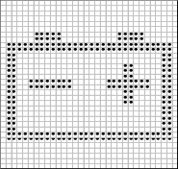


Pixel Definition M.01

For actual symbol definition see pixel definition section in the message center section. The pixel representation is based upon the symbol definition database # M.01 of the 03-0685 ARL requirement

Indicator Color Coordinates

Red - Reference SDS IL-0017/IS-0379 (Color must be red to insure regulatory
compliance – monochromatic RTT not allowed).

Indicator Characteristics

Pixel Display in Message Center Display - Battery Charge RTT

Audio

As per section 1.3.5.1 below.

Switch Control Logic

Not Applicable

System Accuracy

The state of the RTT and warnings shall change within 100msec of a state change as indicated in the state matrix, reference 1.3.5.1 Subsystem Algorithm Flowchart / State Diagram

Operation: Performance and Functional

Subsystem Algorithm Flowchart / State Diagram

Figure 2: Battery Charge Diagnostic Routine Diagram
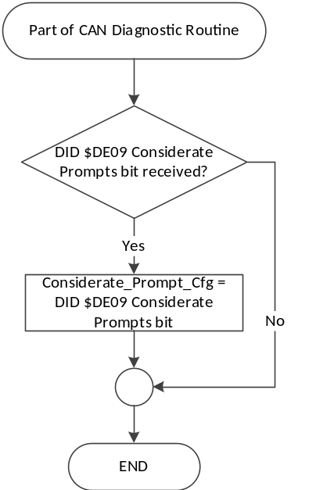

Table 1.2 State Matrix for Battery Charge RTT Flags
Operational_  Mode | DIAG_SESSION  _TIMER | DIAG_DID_  61A4,1,0 (Charge Warning) | PwSysULoFalt_D_Stat Signal | Battery_Charge_RTT
Normal or Crank | Inactive | X | 0x1, 0x2, 0x4, 0x5, 0x8 | Active
Normal or Crank | Inactive | X | Missing as per 1.4.1 | Active
Normal | Active | Not Received | 0x1, 0x2, 0x4, 0x5, 0x8 | Active
Normal | Active | Not Received | Missing as per 1.4.1 | Active
Normal | Active | (ON) 0x1 | X | Active
All Other Cases |  |  |  | Inactive
X = Don’t Care
Not Received = The state when a DIAG_SESSION_TIMER is active and the DID has not been received

Table 1.3 State Matrix for Charging System Warning MC Status Flags
Operational_  Mode | PwSysULoFalt_D_Stat Signal | Charging_System_  Service_Now_  MC_Warn_Status_Flag | Charging_System_  Service_Soon_  MC_Warn_Status_Flag | Battery_SoC_Low_  MC_Warn_Status_Flag
Normal or Crank | 0x2, 0x4, 0x5, 0x8 | Active | Inactive | Inactive
Normal or Crank | 0x3, 0x9 | Inactive | Active | Inactive
Normal or Crank | 0xE | Inactive | Inactive | Active
Normal or Crank | Missing as per 1.4.1 | Inactive | Inactive | Inactive
All Other Cases |  | Inactive | Inactive | Inactive

Table 1.4 Charging_System_Service_Now_Warning_Classification_Flag
Considerate_Prompt_Cfg | Fuel_Station_Considerate_  Prompt_Available_Flag | Charging_System_  Service_Now_  MC_Warn_Status_Flag | Charging_System_  Service_Now_  Warning_Classification_Flag
0x1 (Enabled) | 0x0 (Inactive) | Active | 0x0 (Non Considerate Prompt Warning)
0x1 (Enabled) | 0x1 (Active) | Active | No State Change
0x1 (Enabled) | X | Inactive | 0x1 (Considerate Prompt Warning)
0x0 (Disabled) | X | X | 0x0 (Non Considerate Prompt Warning)

Table 1.5 Charging System Warning MC Status Flag to MC Warning Message ID
Charging_System_  Service_Now_  MC_Warn_Status_Flag | Charging_System_  Service_Soon_  MC_Warn_Status_Flag | Battery_Soc_Low_  MC_Warn_Status_Flag | MC Message ID
Active | Inactive | Inactive | Reference Table 1.6
Inactive | Active | Inactive | W3275
Inactive | Inactive | Active | W3277

Table 1.6 Charging System Warning IDs for Considerate Prompts
Charging_System_Service_Now_  MC_Warn_Status_Flag | Charging_System_Service_Now_  Warning_Classification_Flag | Warning Displayed
Active | 0x0 (Non Considerate Prompt Warning) | W3276
Active | 0x1 (Considerate Prompt Warning) | W4015

Table 1.7 Charging System Warning MC Status Flag to MC Warning Chime Flag
MC Warning Status Flag | MC Warning Chime Flag
Charging_System_Service_Now_MC_Warn_Status_Flag | Message_Center_Hard_Warning_Chime_Status_Flag
Charging_System_Service_Soon_MC_Warn_Status_Flag | Message_Center_Soft_Warning_Chime_Status_Flag
Battery_Soc_Low_MC_Warn_Status_Flag | Message_Center_Soft_Warning_Chime_Status_Flag

Operation Description (supports algorithm flowchart /state diagram)

- The actual RTT display operational modes are displayed in the Message Center Section of this SPSS.
- For definition of how the Message Center arbitrates and displays Active warnings, see the Warning / Alert Display Logic Diagram, located in the Message Center – X Display with W Button Interface section of this SPSS (where X and W are appropriate values in this document).
- For applications not capable of displaying a red RTT this STSS is implemented without the RTT (text only), however, if this is done then a Fixed LED red telltale must be implemented as per “Battery Charge Telltale – CGEA1.3” STSS.
- Important: FOR ALL MARKETS if the text warning in this STSS is implemented without a red RTT then a Fixed LED red telltale as per “Battery Charge Telltale – CGEA1.3” STSS is REQUIRED to ensure worldwide regulatory compliance.

Function Safety Classification (EMC)

Class B

Memory Storage

Parameter Name | Description | Value at  Battery Connect | Value at  Module Wake-up
Battery_Charge_RTT | Used to control the state of the Reconfigurable Telltale | Inactive (0x0) | Inactive (0x0)
Charging_System_Service_  Now_MC_Warn_Status_Flag | Internal flag used to control the state of the Warning | Inactive (0x0) | Inactive (0x0)
Charging_System_Service_  Soon_MC_Warn_Status_Flag | Internal flag used to control the state of the Warning | Inactive (0x0) | Inactive (0x0)
Battery_SoC_Low_MC_Warn_  Status_Flag | Internal flag used to control the state of the Warning | Inactive (0x0) | Inactive (0x0)
PwSysULoFalt_D_Stat Signal | CAN signal sent from the BCM | No_Fault (0x0) | No_Fault (0x0)
DIAG_DID_61A4,1,0 (Charge Warning) | Warning Lamp Status 1, byte 1, bit 0 (Charge Warning) | OFF (0x0) | OFF (0x0)
Operational_Mode | 4 state indicator for cluster operational mode | Limited | Limited, Normal or Crank
Message_Center_Hard_Warning_Chime_Status_Flag | Used to control the state of the chime to the Chime Arbitrator | Inactive | Inactive
Message_Center_Soft_Warning_Chime_Status_Flag | Used to control the state of the chime to the Chime Arbitrator | Inactive | Inactive
Considerate_Prompt_Cfg | State indicator for feature presence controlled via CAN at EOL at VO plant. Set to disabled at Cluster Supplier Manufacturing Plant | Use Stored Value | Use Stored Value
Fuel_Station_Considerate_  Prompt_Available_Flag | Internal variable indicating when Fuel Station Considerate Prompts are available. | 0x0 (Inactive) | 0x0 (Inactive)
Charging_System_Service_  Now_Warning_Classification_Flag | Internal variable indicating if the warning associated with Charging_System_  Service_Now_MC_Warn_Status_Flag is a Non-Considerate Prompt (0x0) or a Considerate Prompt (0x1). | 0x0 (Non-Considerate Prompt) | 0x0 (Non-Considerate Prompt)

Parameter Name | Description | Value at  Battery Connect | Value at  Module Wake-up
DIAG_SESSION_TIMER | Timer used to time-out a diagnostic session | Inactive | Inactive

Prove Out

No

Reconfigurable Telltale

Yes

Message Center Msg

See Message Center Section for strategy of displaying RTT based upon state of RTT flag. Warning message IDs as per table 1.4.

Error Handling

Missing Message Strategy

The signals will be declared missing as per the Diagnostics section of this SPSS.

DTCs states and history will be determined as per the Diagnostics section of this SPSS.

Diagnostics

Self Test

None

Engineering Test Mode

Reference section “Dealer / Engineering Test Mode (ETM)”

Part II Performance

Supported Diagnostic DIDs (Service $22 and $2F)
Number | DID / CommonID Name | DID Type
61A4 | Warning Lamp Status 1, byte 1, bit 0 (Charge Warning) | Bit Mapped

Supported Diagnostic Trouble Codes (DTCs)
DTCs shall be logged as per the diagnostic section of this SPSS.*

DTC | Description
C14000 | Lost Communication With Body Control Module
C43182 | No Update With Body Control Module
* If the missed signal has an _UB signal, the NO Update DTC is to be logged. Otherwise, the Lost Communication DTC is logged.

DID DExx Configuration
Block  Num | Block Description | Byte(s) | Bits | State: Description | "0" | "1" | Default | Comments/Information
PACKETED BLOCKS
$09 | Option Content (B&A) | * | * | Considerate Prompts | Disabled | Enabled | Disabled | Disabled means the Considerate Prompt feature (menu, warnings, and chimes) is not present in the vehicle. Enabled means Considerate Prompt warnings and menus may be displayed and chimes sounded when conditions are met.
*Byte and bit location to be identified in Part II Specification for this cluster

Reference Specification

EC-0058 LOW/HIGH VOLTAGE GUARANTEED FUNCTION/PERFORMANCE

IS-0001 WARNINGS/INDICATORS/DISPLAYS PROVEOUT
IS-0046 INSTRUMENTATION MATERIAL RESISTANCE TO CLEANING
IS-0052 OPERATING VOLTAGES - FUNCTIONAL/PERFORMANCE
IS-0069 FUNCTIONAL IMPORTANCE CLASS
IS-0324 WINDSHIELD & OTHER REFLECTIONS
IS-0327 WARNING INDICATOR EVALUATION
IS-0379 NORTH AMERICAN WARNINGS AND INDICATORS STRATEGY

IL-0017 TELLTALE AND INTERIOR ILLUMINATION COLOR
IL-0023 CLARITY/LEGIBILITY/READABILITY
IL-0025 INTERIOR ILLUMINATION INTENSITY
IL -0027 VISUAL CONTRAST
IL -0045 COLOR
IL -0047 TELLTALE; INDICATOR AND DISPLAY LIGHT INTENSITY
IL -0048 ILLUMINATION ACCEPTABILITY

03-0661 PLACEMENT: CONTROL AND DISPLAY LOCATIONS
03-0664 PLACEMENT: DOWN VISION TO COMPONENTS WITH HIGH VISUAL DEMAND
03-0665 PLACEMENT: EXPECTED LOCATIONS OF CONTROLS AND DISPLAYS VDS
03-0670 INTERIOR VISIBILITY
03-0671 INTERIOR VISIBILITY: REFLECTIONS FROM COMPONENTS & SURFACES
03-0672 INTERIOR VISIBILITY: REFLECTIONS IN DISPLAYS
03-0673 INTERIOR VISIBILITY: VISUAL OBSCURATIONS
03-0674 INTERIOR VISIBILITY: ILLUMINATION CONTROLS / DISPLAYS
03-0675 INTERIOR VISIBILITY: VEILING GLARE
03-0677 INTERIOR VISIBILITY: SUNLIGHT WASHOUT
03-0681 IDENTIFICATION: CHARACTER AND SYMBOL SIZE
03-0682 IDENTIFICATION: LEGIBILITY
03-0685 IDENTIFICATION: SYMBOLS, ABBREV FOR CONTROL
03-0721 LOGIC OF OPERATION: OPERATIONAL STEREOTYPES
03-0722 LOGIC OF OPERATION: INTERPRETATION
03-0723 LOGIC OF OPERATION: USE OF SYSTEMS WITH VISUAL DISPLAYS

Revision History
SPSS Module Revision History

Revision Level | Name | Change Description | Date
1.0 | V. Patel | Updated for CGEA 1.3 based on CGEA STSS v2.0  Section 1.2.2 – Removed table referencing the HS-CAN message that contains the input signal.  Section 1.4 – Rewritten. Deleted references of specific missing message flags and timer.  Section 1.5.3 – Deleted DTC logging criteria from the table. | 4/9/2010
1.1 | V. Patel | Changed Input Signal from PowerSystemStatus to PwSysULoFalt_D_Stat as per CGEA 1.3 GSDB.  Section 1.3.5.1 – Updated input criteria in Table 1.2 based on the signal data. | 7/12/2010
1.2 | S. Watkins | Section 1.3.3.1.1, changed warning ID from W710 to W155 | 5/11/2011
1.3 | S. Watkins | Request from Michael Irby, Power Supply Supervisor, to remove state 0x6 of signal PwSysULoFalt_D_Stat as a reason to Activate the RTT. This is to align with Global Power Supply requirements starting with CD4 for CGEA 1.3.  - Section 1.3.5.1, Table 1.2 – Changed first row, 4th column from “0x2 – 0x6, 0x8” to “0x2 – 0x5, 0x8”. Same change made in row 3 as well. | 8/8/2011
2.0 | V. Patel | Major update to the spec to introduce 3 new warnings and splitting the RTT between Red and Amber based on severity of the fault from the power supply.  - Section 1.1: Updated description to show inclusion of warnings in the function.  - Section 1.2.1, figure 1; Section 1.2.3:  Split RTT into two outputs, one for Red RTT, one for Amber.  Added outputs for the 3 new MC Warning Status flags.  - Section 1.2.2, table 1.1: Updated table to show 2 new states in the input signal.  - Section 1.3.3.1.2: Added Amber RTT color reference specification.  - Section 1.3.3.2: Updated statement to include warning chime activation for the 3 new warnings.  - Section 1.3.5.1, table 1.2: Updated table to process Amber and Red RTTs. Added and modified the input states that activates each of the RTTs.  - Section 1.3.5.1, Table 1.3: Created new table to process the 3 new warnings.  - Section 1.3.5.1, Table 1.4: Created table to map the warnings to message center IDs.  - Seciton 1.3.5.1, Table 1.5: Created table to map the warnings to message center warning chime flags.  - Section 1.5.4: Updated table to include Init states of the RTTs and new warning flags. | 4/11/2013
2.1 | V. Patel | - Removed “Battery_Charge_RTT_Amber” from the requirements as per direction from Power System group (M. Irby and F. Mozip) and approval in the DI change control. (6/27/2013)  - Changed “Battery_Charge_RTT_Red” to “Battery_Charge_RTT” due to removal of amber RTT.  - Section 1.3.3.1.1: Removed reference to message center warning W155 as it is not applicable anymore. That warning has been replaced by the warnings in table 1.3  - Fixed all the table numbers in section 1.3.5.1 (they were previously mis-aligned).  - Added note in the functional description (section 1.1) for clusters that have telltale (instead of the RTT) and capability to display text messages to refer to the “Battery Charge Telltale – CGEA1.3” STSS for telltale implementation.  - Section 1.5.3, DTC table: Added a row for invalid data DTC. | 7/10//2013
2.2 | S.Watkins | Corrected Invalid DTC, section 1.5.3. | 7/30/2013
2.3 | J.Blatchford | This change clarifies usage without RTT. DCR not required unless warning text is implemented without RTT or TT – Otherwise new programs only.  1.1: Added last paragraph. Modified second to last paragraph.  1.3.3.1.2: Added note relative to color.  1.3.5.2: Added bottom 2 notes. | 10/9/2013
2.4 | Ilopezla | This updates adds Chime Status Flags associated to this warning  (all changes are highlighted light blue)  Section 1.2.1 Figure 1 Added -XX_Chime_Status_Flag  Section 1.2.3 Added- Message_Center_Hard_Warning_Chime_Status_Flag  Message_Center_Soft_Warning_Chime_Status_Flag  Section1.3.5.4 Added-  Message_Center_Hard_Warning_Chime_Status_Flag  Message_Center_Soft_Warning_Chime_Status_Flag  To Memory Storage Table | 1/7/2015
3.0 | J. Gregoire | Changes highlighted in Orange  DI Change Control – 4/20/2017  Add Considerate Prompt for W3276.  Page 1 Figure 1 – Add Considerate_Prompt_Cfg, Fuel_Station_Considerate_Prompt_Available_Flag, and Charging_System_Service_Now_Warning_Classification_Flag.  Page 2 Section 1.2.2 – Add Considerate_Prompt_Cfg and Fuel_Station_Considerate_Prompt_Available_Flag.  Page 2 Section 1.2.3 – Add Charging_System_Service_Now_Warning_Classification_Flag.  Page 4 Figure 2 – Add figure for Considerate_Prompt_Cfg.  Page 5 Table 1.4 – New table for Charging_System_Service_Now_Warning_Classification_Flag.  Page 5 Table 1.5 (was 1.4) – Update W3276 to reference Table 1.6  Page 5 Table 1.6 – New table for Considerate Prompt warnings.  Page 6 Section 1.3.5.4 – Add Considerate_Prompt_Cfg, Fuel_Station_Considerate_Prompt_Available_Flag, and Charging_System_Service_Now_Warning_Classification_Flag.  Page 7 Section 1.5.3 – Add Considerate_Prompt_Cfg. | 6/14/2017

